**Project name**  **:** Safe Horn.

**Idea**   **:**

Now a days we seen more accidents on highways due to negligence or don’t have a scope to see dangerous steps taken by surrounded vehicles.

**Situation :**

let us consider a situation where driver in a car at a highway where there is rainfall.So he closed all the windows and driving a car. Suddenly a vehicle from back side try to overtake the car by giving a horn signal, but the driver didn’t hear that horn it makes a terrible accident as shown.



**Solution :**

We will fix a horn inside of car and fix a sensor at vehicle b ack

now whener a vehicle Wants to cross the front vehicle then there is intimation inside the car. 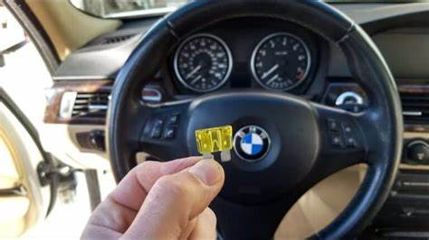

**Objectives**  :

**Hardware components**

1. Arduino Uno R3 board
2. Ultrasonic sensor (HC-SR04)
3. 16×2 LCD I2C Display
4. Jumper Wires

**Procedure:**

1. Connect the Echo pin of the sensor to the D2 pin of the Arduino.
2. Connect the Trig pin of the sensor to the D3 pin of the Arduino.
3. Navigate to Tools and select board and port.
4. Verify and compile the code, then upload the code to the Arduino Uno R3 board.
5. Monitor the output in the Serial monitor (Set the baud rate as 9600). To open Serial monitor Tools>Serial Monitor or (Ctrl+Shift+M).

Arduino Code (Output in Serial monitor):

The following code will show the output on the serial monitor of Arduino software with a baud rate of 9600.

#define echoPin

#define trigPin

long duration;

int distance;

void setup()

{

pinMode(trigPin,OUTPUT);

pinMode(echoPin, INPUT);

Serial.begin(9600);

Serial.println("Distance measurement using Arduino Uno.");

delay(500);

}

void loop()

{

digitalWrite(trigPin, LOW);

delayMicroseconds(2);

digitalWrite(trigPin,HIGH);

delayMicroseconds(10);

digitalWrite(trigPin,LOW);

duration=pulseIn(echoPin, HIGH);

distance=duration * 0.0344 / 2;

Serial.print("Distance: ");

Serial.print(distance);

Serial.println(" cm");

delay(100);

}

